Title (Times New Roman, 15pt, left alignment, bold)

Alan H. Schoen^{1,*}, First Middle Surname², First Middle Surname^{1,2}
(Times New Roman, 12 pt, underline the presenting author, left alignment)
¹Example Research Institute, Address, Some Country
²Times New Roman Italic 10 pt
*email: gyroidiseverywhere@gmail.com

This word.docx file serves as a sample abstract. The text must fit a single A4 page (297×210 mm; 11.7×8.3 inch). Change the text (Times New Roman, 11 pt) and the figure. It is advisable to include one to three references [1-3]. Moreover, it is recommended to integrate one to three figures for enhanced illustration. Lastly, kindly submit a one-page PDF file via the conference webpage.
Below a portion from Schoen’s NASA technical Note D-5541 (1970).
A preliminary account of a study of the partitioning of three-dimensional Euclidean space into two interpenetrating labyrinths by intersection-free inﬁnite periodic minimal surfaces (IPMS) is given. A construction algorithm for deriving such surfaces leads to the identiﬁcation of the ﬁve cases already known, plus a number of new examples.
By the use of this algorithm and other methods, a total of seventeen intersection-free IPMS have been identiﬁed. Photographs of plastic models and computer-generated drawings of examples of such sur-faces are shown. Also described and illustrated is an example of a non-orientable IPMS, generated from a skew pentagonal surface module. A counterpart to Schoenﬂies’ proof that there exist only six quadrilateral modules of IPMS is mentioned: There exist only eight pentagonal modules of IPMS having non-cubic Bravais lattices.
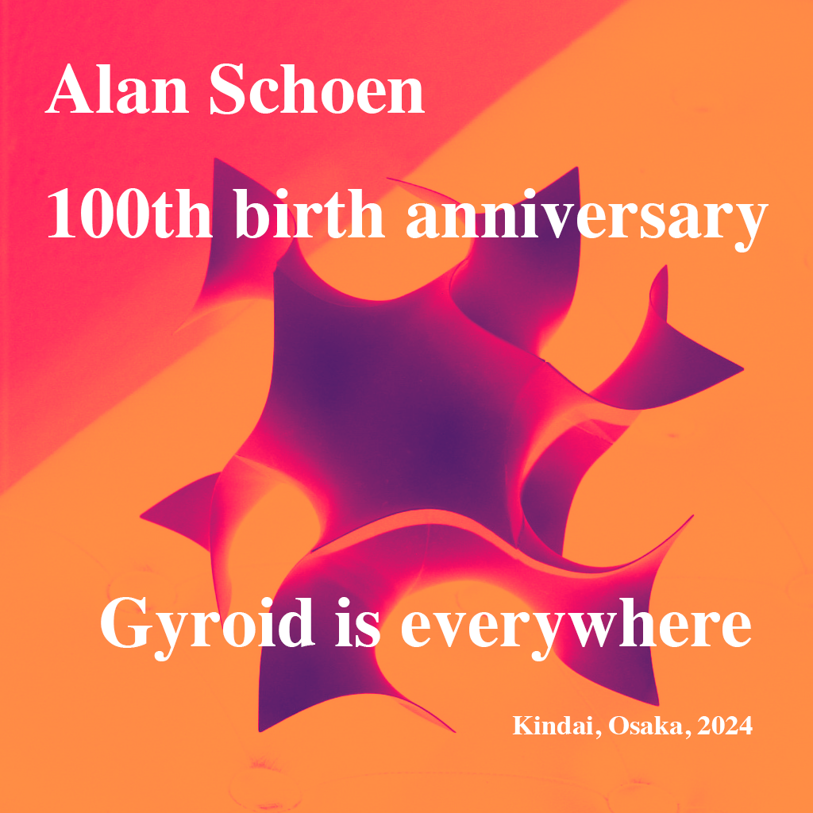
Figure 1 Figure legend. (Times New Roman, 9 pt)

The ﬁve published examples of inﬁnite periodic minimal surfaces (IPMS) which are free of self-intersections are as follows. In 1865, the ﬁrst published example of an inﬁnite periodic minimal sur-face (IPMS) was described by H. A. Schwarz ref. 1. This surface was also studied in memoirs published independently by Riemann and by Weierstrass. In Schwarz’s analysis, which is described by Darboux (ref. 2) as deeper and more comprehensive than that of his contemporaries, the analytic solution for the surface is expressed in terms of the Weierstrass parametrization for minimal surfaces. We call this surface, which has symmetry related to that of the diamond crystal structure, Schwarz’s diamond surface, or D. A ﬁnite portion of D is shown in Figure 1.
A surface which is adjoint (i.e., conjugate under bending according to Bonnet’s transformation (ref. 3)) to D, which we call the primitive surface, or P, was also described by Schwarz. P, illustrated in Figure 2, has symmetry related to that of the primitive cubic lattice. The Bravais lattice (lattice of translational symmetry) for D is face-centered-cubic (F); the Bravais lattice for P is the primitive cubic lattice (P). A fundamental region of P or D is of genus 3.
This work was supported by ABC (Times New Roman Italic 11 pt, optional).
[1] A. H. Schoen, Interface Focus, 2, 658 (2012).
[2] O. Hundred, B. Anniversary, Journal name, 12, 11 (1924).
[3] G. Lastname, I. Lastname, E. Lastname, Journal name, 11, 19 (2024).
Links (optional)

